Marketing Committee Report
Grande Prairie Residential Society | Board meeting of ______________
Submitted by Thomas Cheesman
Since the last meeting
- Ongoing upkeep of the Society website — corrections, small improvements, and keeping pages current.
- Published updates on the Margaret Edgson Manor rebuild so that residents, families and donors can follow progress in one place rather than by word of mouth.
- Confirmed the site is being found — by search engines, and now by the AI assistants people increasingly use instead of a search box. That matters for how a family looking for accessible housing finds us.
This was maintenance rather than a campaign. No spending, no new commitments.
Website traffic this summer
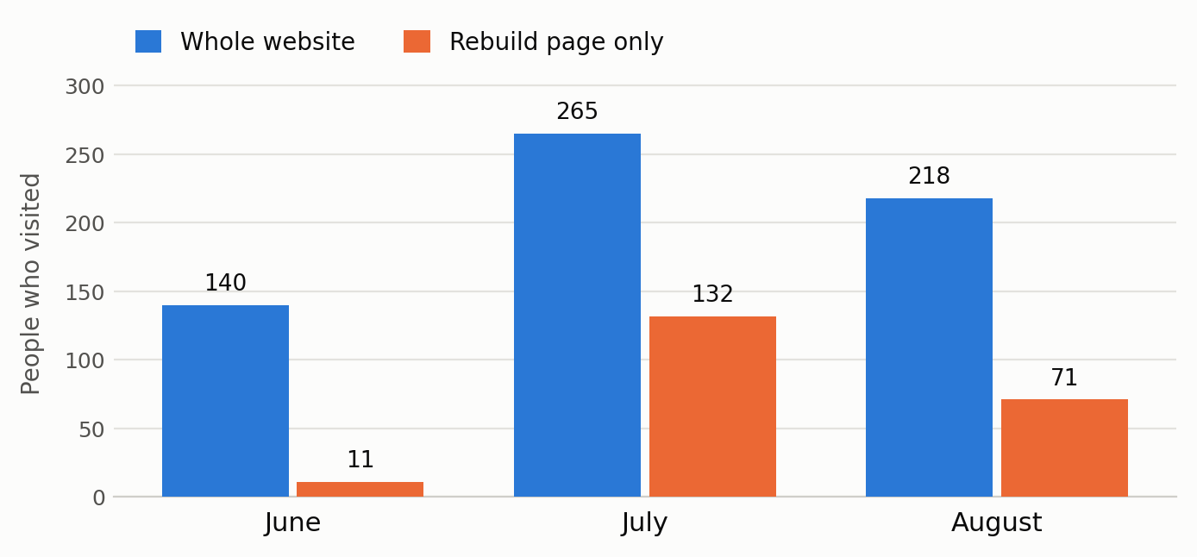
People who visited the Society website, June to August 2026. Google Analytics. June and July figures are from Google’s 28-day reporting periods (June 3–30, July 1–28); August is the full month.
Traffic nearly doubled in July and stayed well above June through August. The rebuild page drove it: 11 people read it in June, 132 in July, 71 in August. People are following the Margaret Edgson Manor story, and they are coming back for it.
In August, 78 visitors arrived through a Google search, 37 through Facebook, and 16 from the provincial housing finder at findhousing.alberta.ca — a referral source worth knowing we have. Three quarters of visitors were from Grande Prairie, Edmonton and Calgary.
Item 1 for decision — protecting the Society’s name in email
At present, anyone in the world can send an email that appears to come from the Society. They do not need to break into anything; they simply put our name on the “From” line, the way anyone could print our letterhead at home. Email does not check this unless we tell it to.
We can tell it to. We publish a short public note stating which mail service may send on our behalf; Gmail, Outlook and the others read it and treat anything else as suspicious. Most organizations have one. We do not.
The risk is not to our computers. It is to people who trust us — a donor, a contractor, or a family on the housing list receiving a message that looks like ours, saying our banking details have changed. This is a common scam and nothing currently slows it down.
To be clear: nothing has been broken into — this is a lock we never installed. There is no cost, and our IT contact can put it in place in roughly ten minutes.
Suggested motion: That the Marketing Committee be authorized to instruct the Society’s IT contact to put email sender protection in place for gpresidentialsociety.com, at no cost.
Item 2 for decision — who holds the keys
The Society’s web address is controlled through an account the Society itself does not hold — first a previous volunteer, now our IT contact. No one has done anything wrong and the arrangement has worked. The weakness is succession: if I stepped back tomorrow, the board would have to go looking for who controls what, as happened at the last handover.
I would like us to record, in the Society’s own files, who controls the web address, who controls the website, and who to call — and to decide whether those accounts should be held in the Society’s name rather than an individual’s.
Suggested motion: That the Marketing Committee prepare a written record of the Society’s website and domain accounts, and report back with a recommendation on holding those accounts in the Society’s name.
Coming up
- Continue rebuild updates as information becomes available.
- Act on whichever motions the board approves.

